Assignment 2 Report

ECE 493: Probabilistic Reasoning and Reinforcement Learning

Na Rae Kim

#20607415

July 31st, 2019

Table of Contents

1. Used Algorithms 3

1.1. SARSA 3

1.2. Q-Learning 3

1.3. Expected SARSA 3

1.4. Double Q-Learning 3

2. Test Results 4

2.1. Task 1 4

2.1.1. Overall 4

2.1.2. SARSA 5

2.1.3. Q-Learning 6

2.1.4. Expected SARSA 7

2.1.5. Double Q-Learning 8

2.1.6. More Comparison Graphs 9

2.2. Task 2 10

2.2.1. Overall 10

2.2.2. SARSA 11

2.2.3. Q-Learning 12

2.2.4. Expected SARSA 13

2.2.5. Double Q-Learning 14

2.2.6. More comparison graphs 15

2.3. Task 3 16

2.3.1. Overall 16

2.3.2. SARSA 17

2.3.3. Q-Learning 18

2.3.4. Expected SARSA 19

2.3.5. Double Q-Learning 20

2.3.6. More Comparison Graphs 21

3. Conclusion 22

# Used Algorithms

States used is the coordinates on the canvas (maze), and the actions it can take are up, down, right, and left, defined as number 0, 1, 2, and 3 respectively. Dynamics are, reward is 1 if its next state is the goal, 0.3 if the next state is towards the wall, -10 if the next state is to pit block, or -0.1 in any other cases, cost of each step.

## SARSA

SARSA is an on-policy temporal difference (TD) control. It updates its value function using the Q of the next state $S_{t+1}$ and the current policy’s action $A_{t+1}$.

$$Q\left(S_{t},A_{t}\right)=Q\left(S_{t},A_{t}\right)+ α[R_{t+1}+γQ\left(S_{t+1},A_{t+1}\right)-Q\left(S_{t},A_{t}\right)]$$

It updates the policy using epsilon greedy algorithm with respect to the current estimate, which means with the epsilon probability, it can take a random action, otherwise, it will take the best action it thinks. It converges eventually, but slower than Learning.

## Q-Learning

$$Q\left(S_{t},A_{t}\right)=Q\left(S_{t},A_{t}\right)+ α[R_{t+1}+γ\max_{a}{Q\left(S_{t+1},A_{t+1}\right)}-Q\left(S_{t},A_{t}\right)]$$

Q-Learning is an off-policy TD control, which means it always updates its Q-value with the best action, but takes the action using epsilon greedy algorithm. Thus, there is not guarantee if it will converge. It is also known to overestimate actions under certain conditions due to use of best actions every time to update the Q-value.

In practice, it is often faster and better than SARSA.

## Expected SARSA

$$Q\left(S_{t},A_{t}\right)=Q\left(S_{t},A_{t}\right)+ α[R_{t+1}+γ\sum_{a}{π\left(a | S_{t+1}\right)Q(S_{t+1},a)}-Q\left(S_{t},A_{t}\right)]$$

Instead of the sample value-of-next-state, use the expected value of each action. Expected SARSA performs better than SARSA but costs more because it has to sum through all possible actions.

## Double Q-Learning

$$Q_{1}\left(S_{t},A_{t}\right)=Q_{1}\left(S_{t},A_{t}\right)+ α[R_{t+1}+γ\max_{a}{Q_{2}\left(S_{t+1},A_{t+1}\right)}-Q_{1}\left(S_{t},A_{t}\right)]$$

$$Q_{2}\left(S_{t},A_{t}\right)=Q_{2}\left(S_{t},A_{t}\right)+ α[R_{t+1}+γ\max_{a}{Q_{1}\left(S_{t+1},A_{t+1}\right)}-Q_{2}\left(S_{t},A_{t}\right)]$$

The double Q-learning uses two Q-value functions for update, either update with the first Q-value function in some cases randomly chosen or update second Q-value function in other cases. Because it uses two Q-value functions, this algorithm will do more exploration. It performs well in some settings in which Q-learning performs poorly due to its overestimation.

# Test Results

## Task 1

### Overall

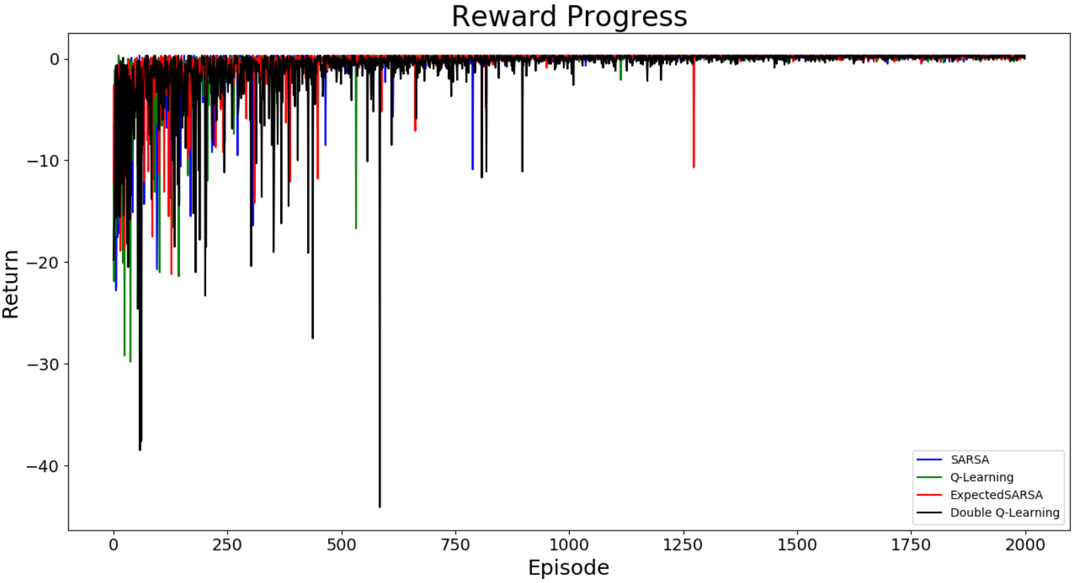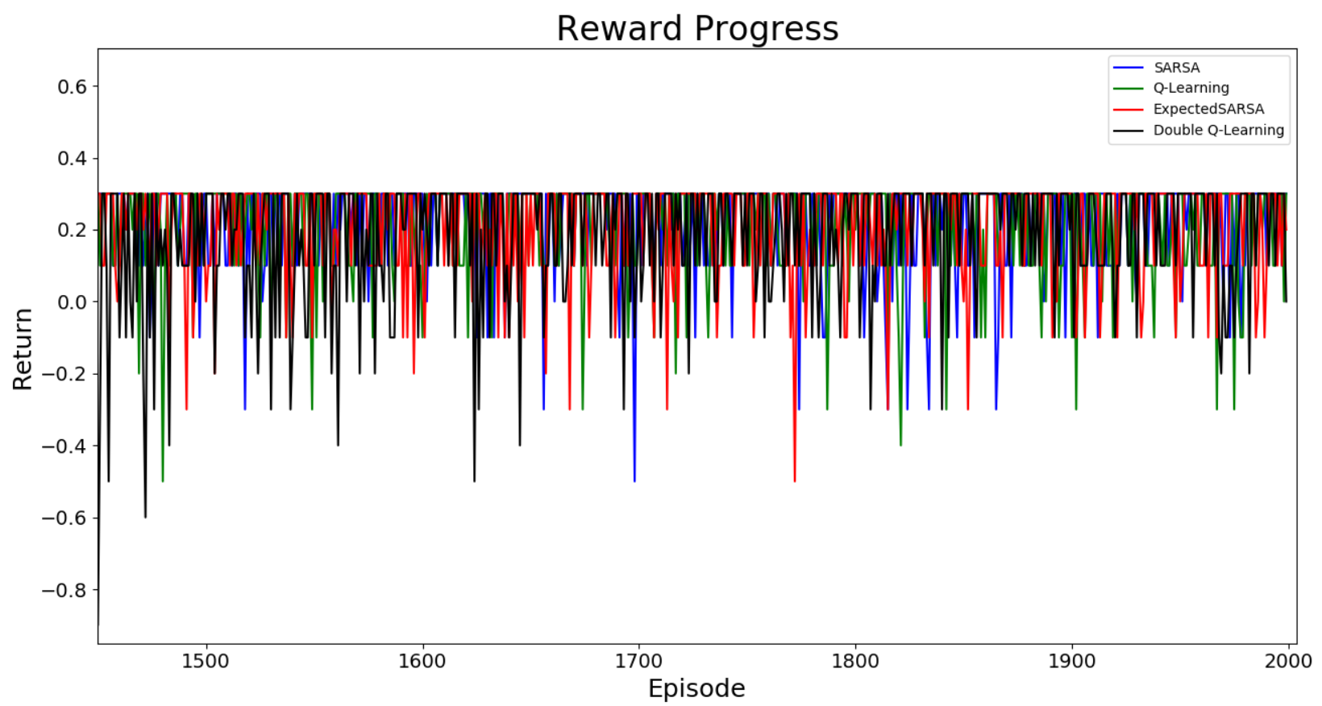

The best value the algorithms can have is 0.3, since it is 8 steps (shortest-path) far from the goal and the reward is calculated till the next state is terminal state. The above figures show the result of learning task 1 using the four algorithms. All four algorithms produced best outputs, but their variances vary. The data below shows the results in numbers, the variances for all algorithms are small enough to be neglected.

SARSA : max reward = 0.3 medLast100=0.3 varLast100=0.026811

Q-Learning : max reward = 0.3 medLast100=0.3 varLast100=0.021131

Expected SARSA : max reward = 0.3 medLast100=0.3 varLast100=0.017411

Double Q-Learning : max reward = 0.3 medLast100=0.3 varLast100=0.017059

### SARSA

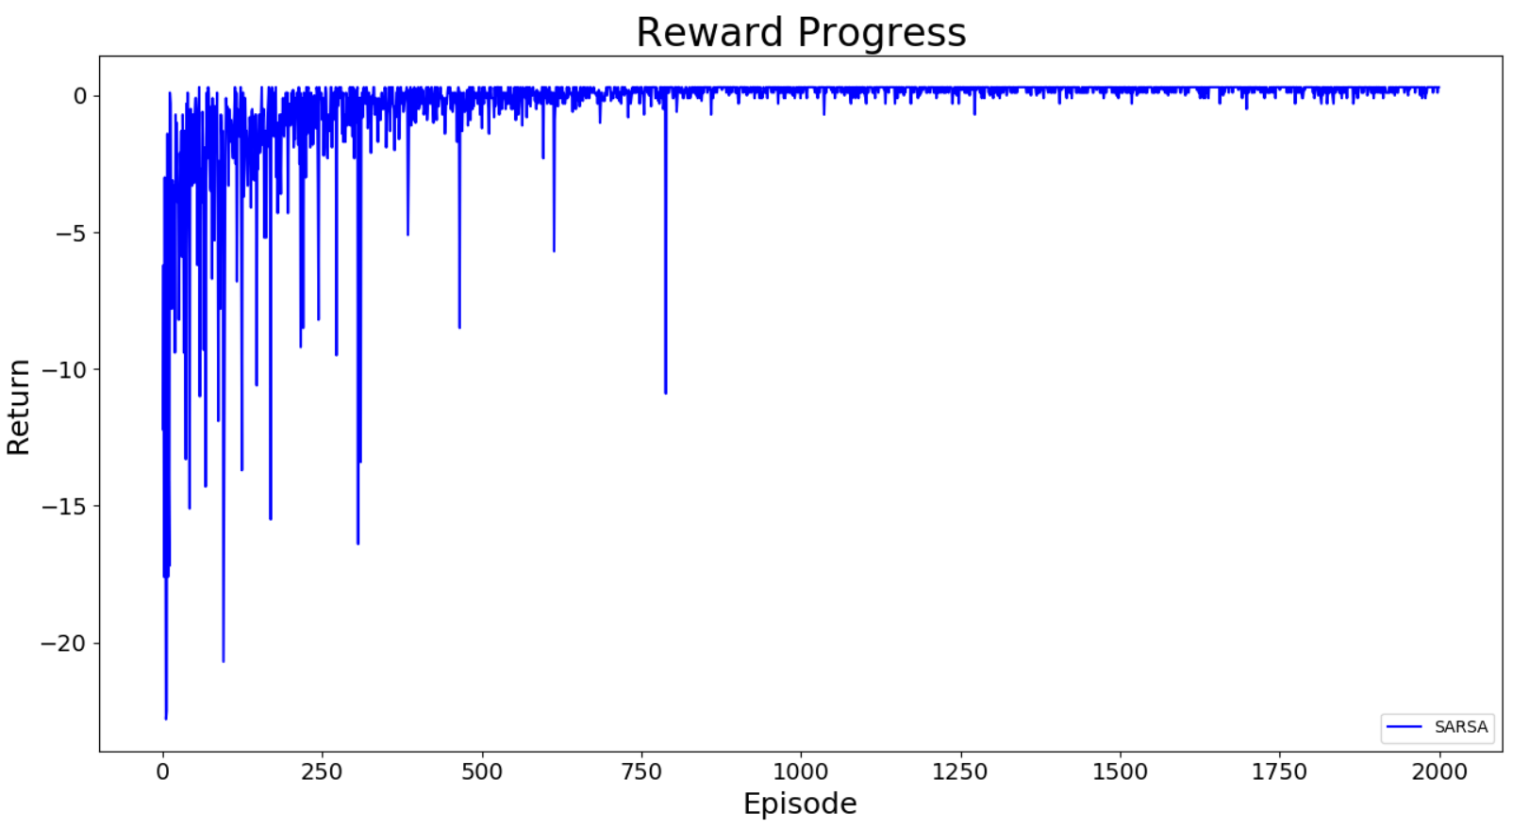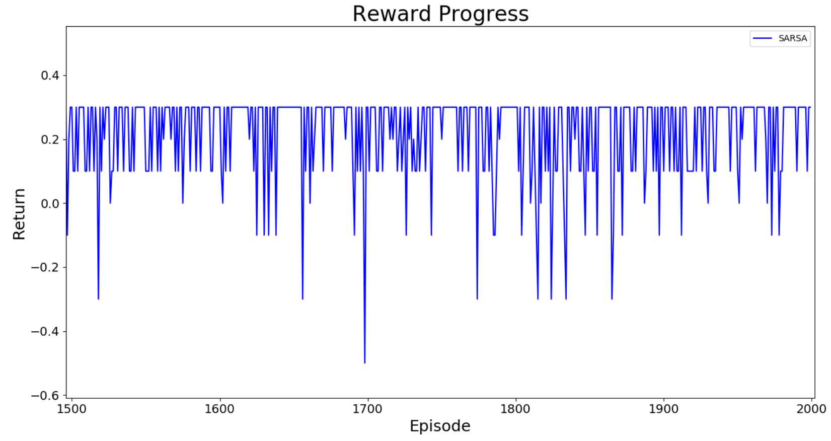

(SARSA) Episode 1500: Length=7 Total return = 0.3Median100=0.3 Variance100=0.015544

(SARSA) Episode 1600: Length=7 Total return = 0.3Median100=0.3 Variance100=0.011771

(SARSA) Episode 1700: Length=7 Total return = 0.3Median100=0.3 Variance100=0.020539

(SARSA) Episode 1800: Length=7 Total return = 0.3Median100=0.3 Variance100=0.013739

(SARSA) Episode 1900: Length=9 Total return = 0.1Median100=0.3 Variance100=0.026811

### Q-Learning

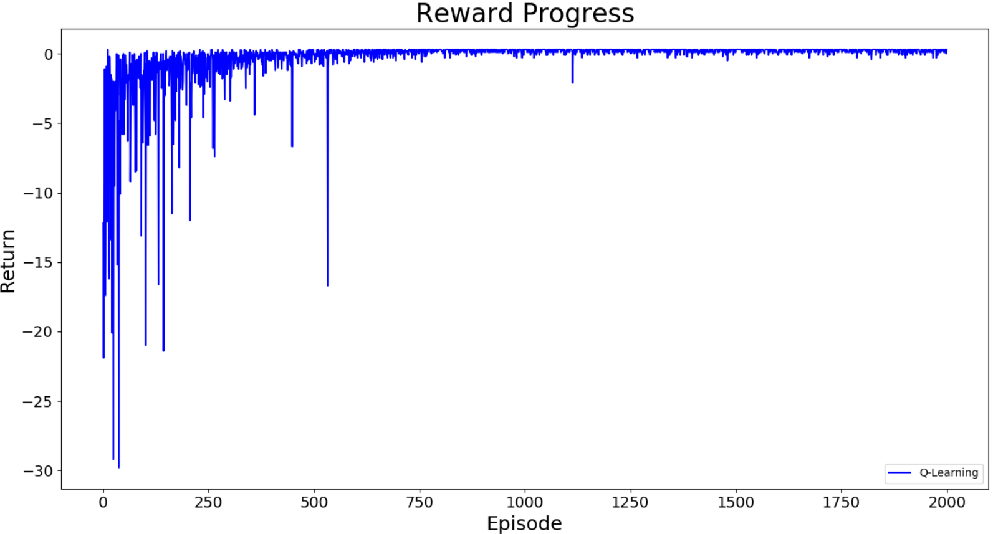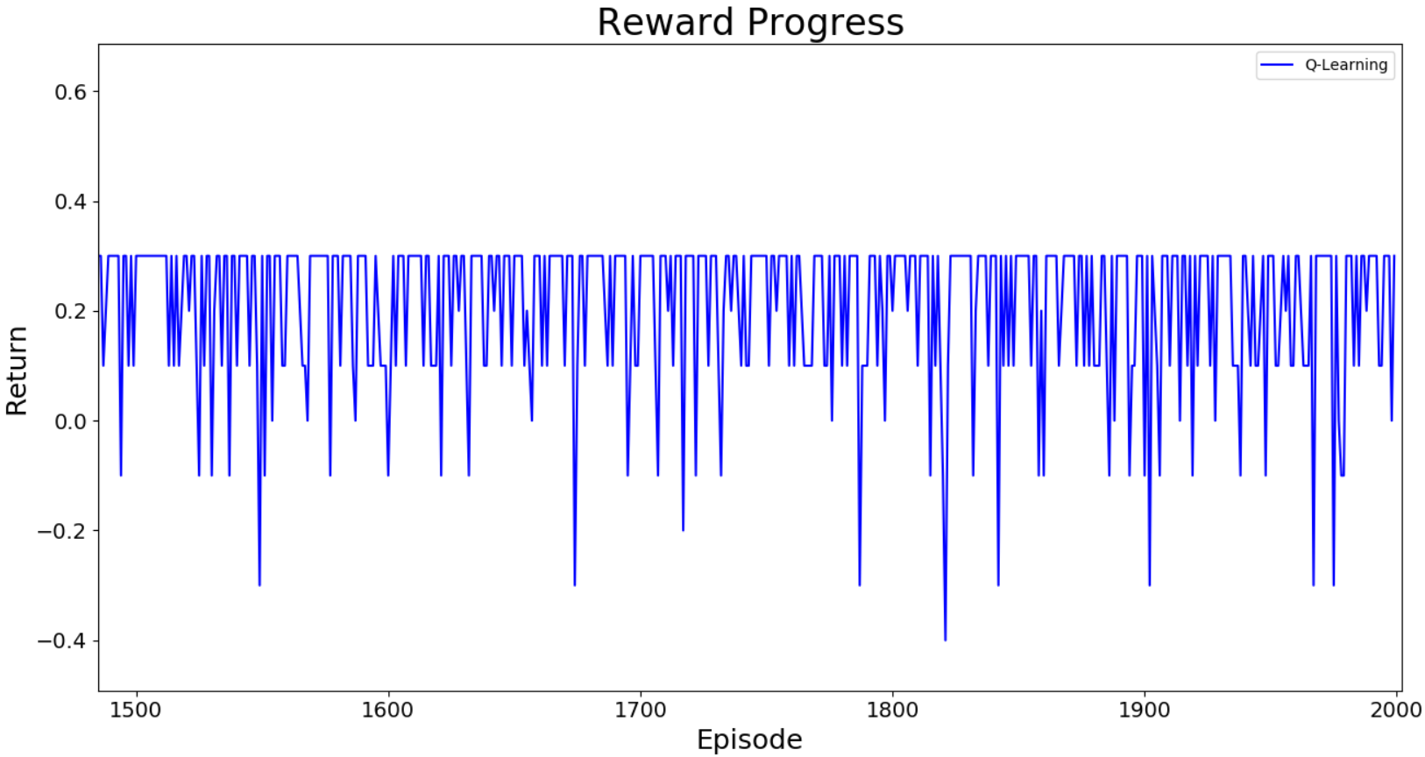

(Q-Learning) Episode 1500: Length=7 Total return = 0.3Median100=0.3 Variance100=0.021075

(Q-Learning) Episode 1600: Length=11 Total return = -0.1Median100=0.3 Variance100=0.016476

(Q-Learning) Episode 1700: Length=7 Total return = 0.3Median100=0.3 Variance100=0.015059

(Q-Learning) Episode 1800: Length=8 Total return = 0.2Median100=0.3 Variance100=0.0158

(Q-Learning) Episode 1900: Length=11 Total return = -0.1Median100=0.3 Variance100=0.021131

### Expected SARSA

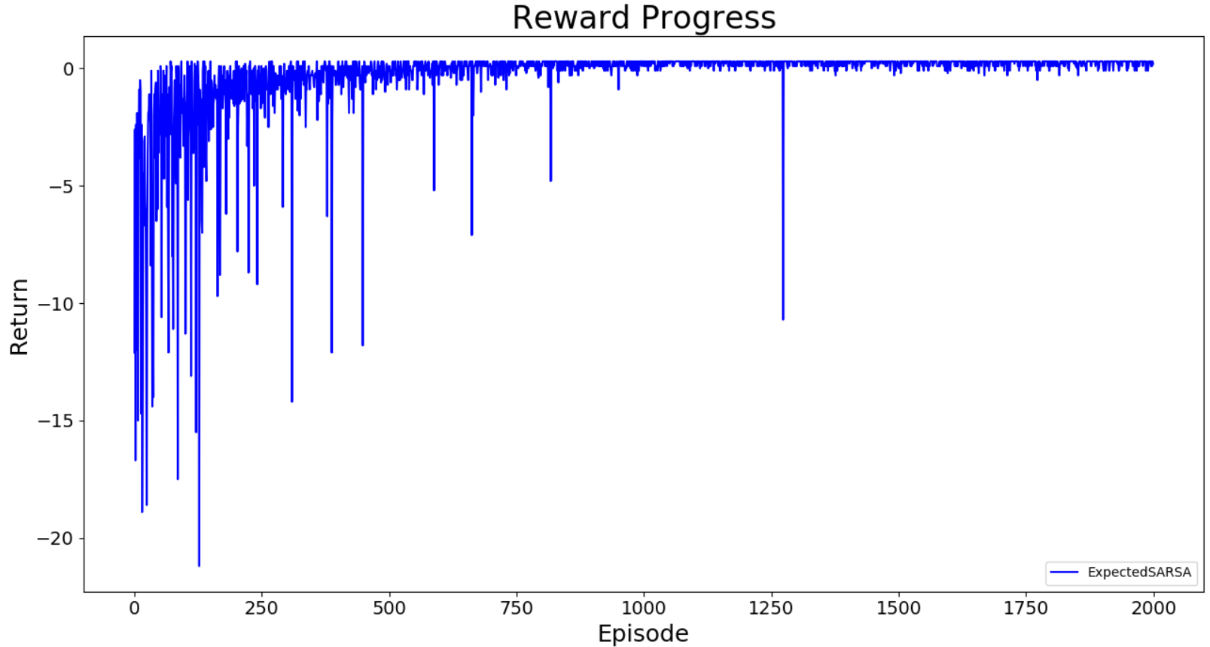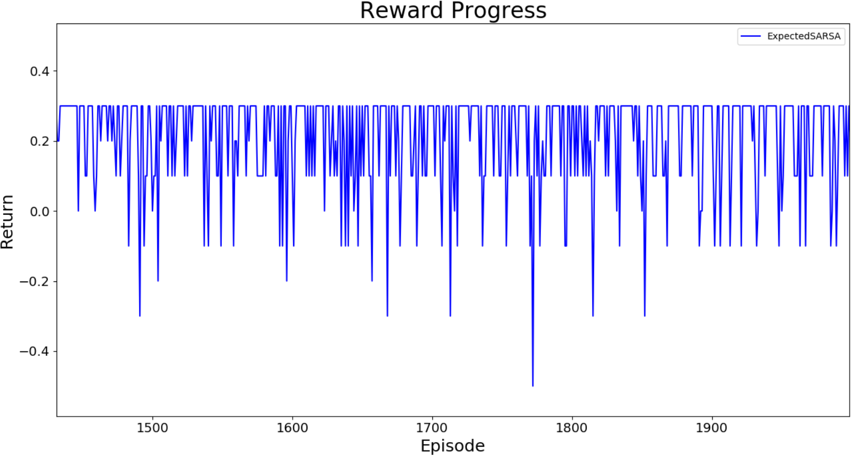

(ExpectedSARSA) Episode 1500: Length=10 Total return = 1.11022302463e-16 Median100=0.3 Variance100=0.014816

(ExpectedSARSA) Episode 1600: Length=9 Total return = 0.1 Median100=0.3 Variance100=0.017056

(ExpectedSARSA) Episode 1700: Length=7 Total return = 0.3 Median100=0.3 Variance100=0.019499

(ExpectedSARSA) Episode 1800: Length=7 Total return = 0.3 Median100=0.3 Variance100=0.023384

(ExpectedSARSA) Episode 1900: Length=7 Total return = 0.3 Median100=0.3 Variance100=0.017411

* + 1. Double Q-Learning

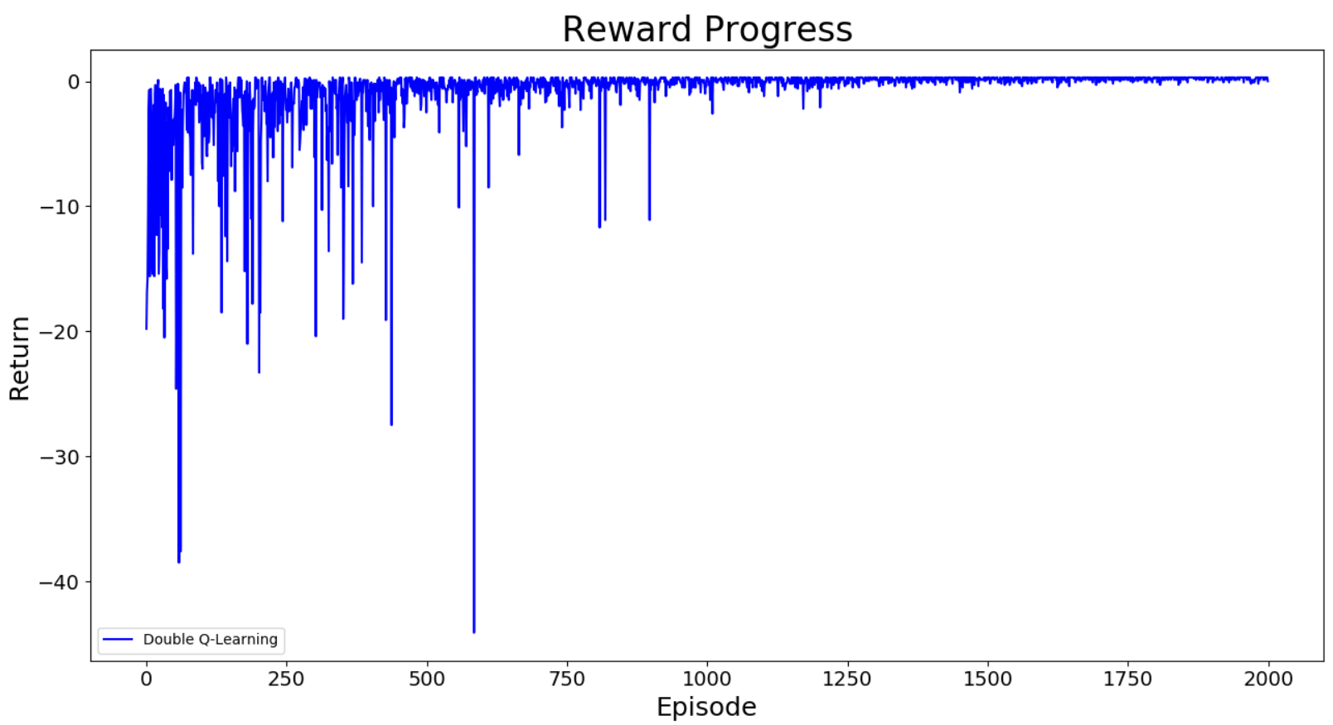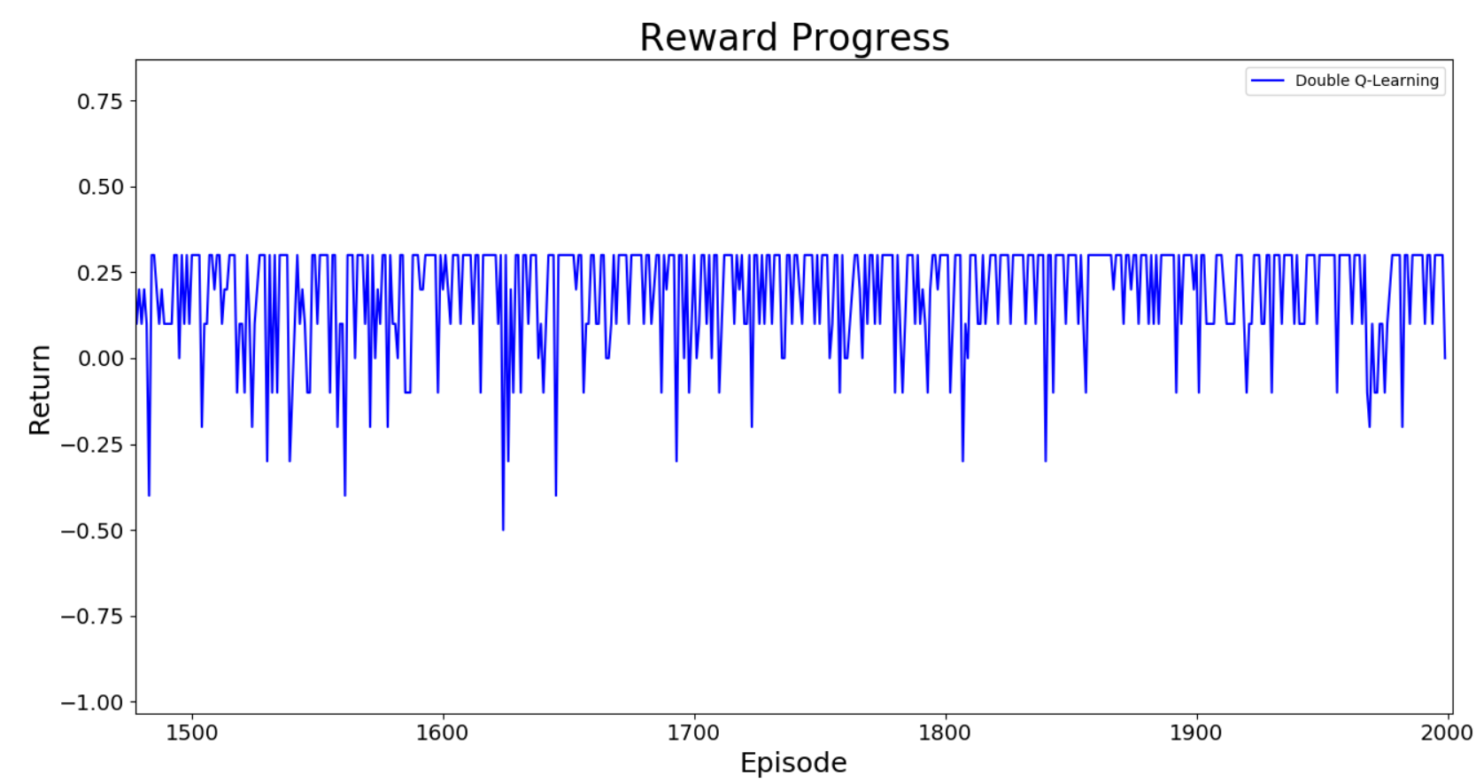

(Double Q-Learning) Episode 1500: Length=7 Total return = 0.3 Median100=0.2 Variance100=0.051771

(Double Q-Learning) Episode 1600: Length=8 Total return = 0.2 Median100=0.3 Variance100=0.033651

(Double Q-Learning) Episode 1700: Length=7 Total return = 0.3 Median100=0.3 Variance100=0.029251

(Double Q-Learning) Episode 1800: Length=7 Total return = 0.3 Median100=0.3 Variance100=0.017196

(Double Q-Learning) Episode 1900: Length=7 Total return = 0.3 Median100=0.3 Variance100=0.017059

### More Comparison Graphs

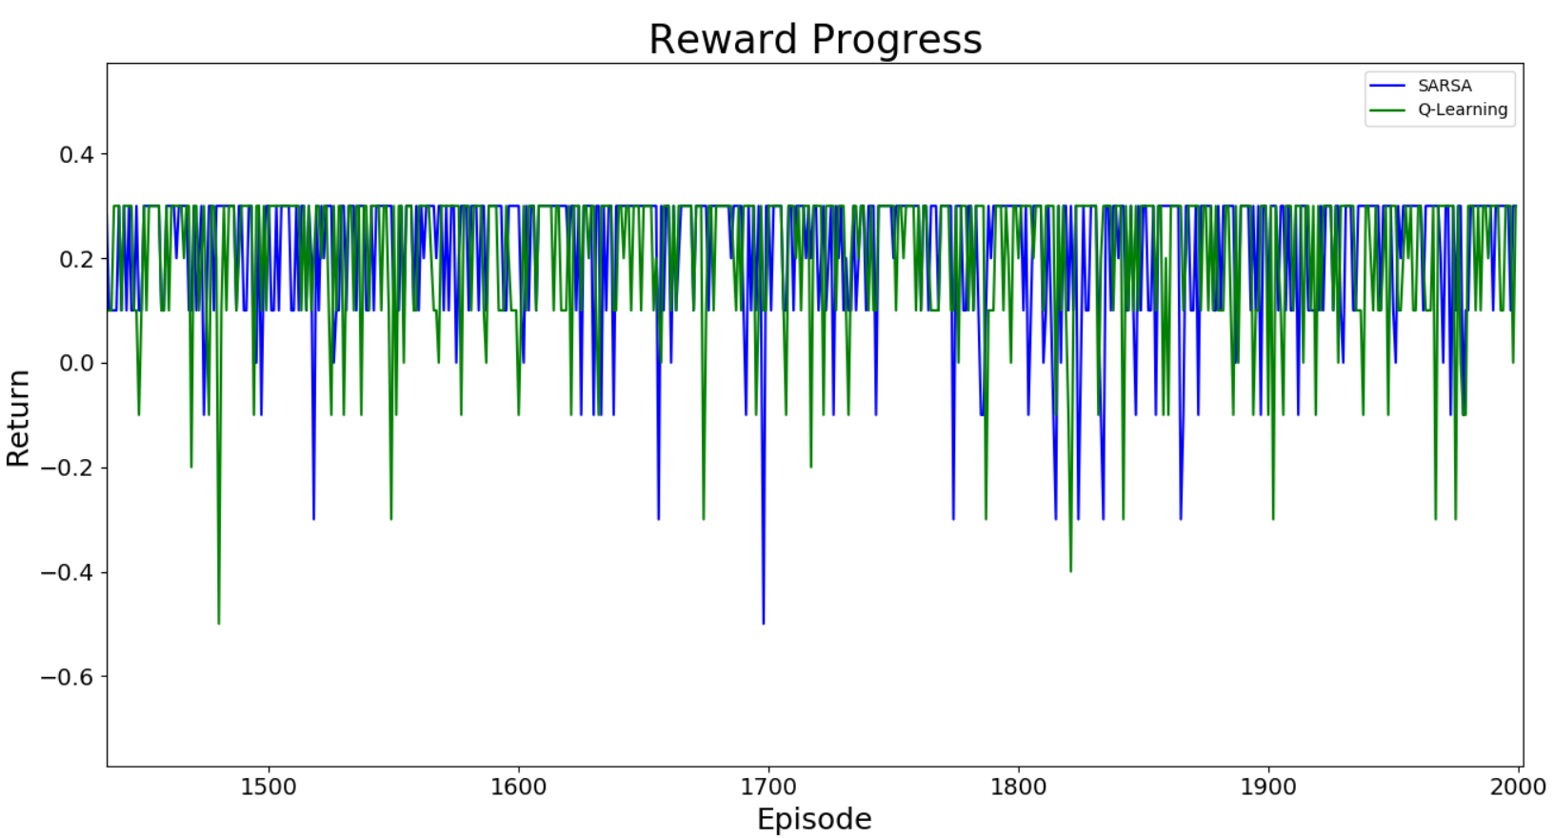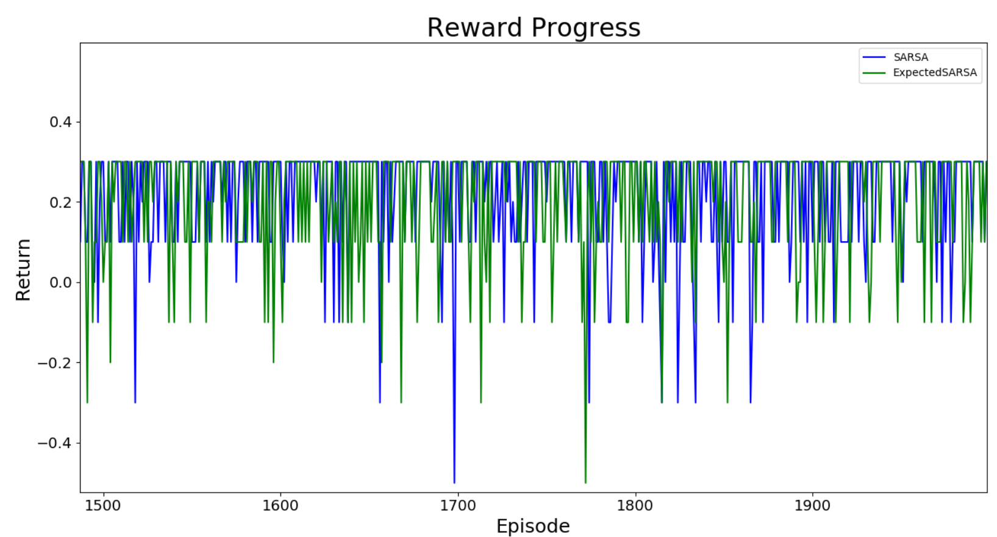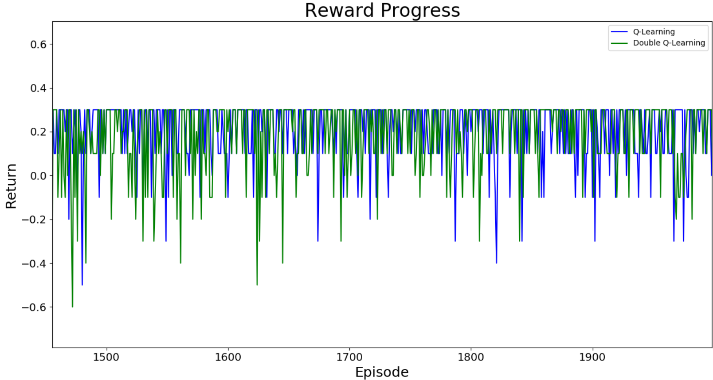

## Task 2

### Overall

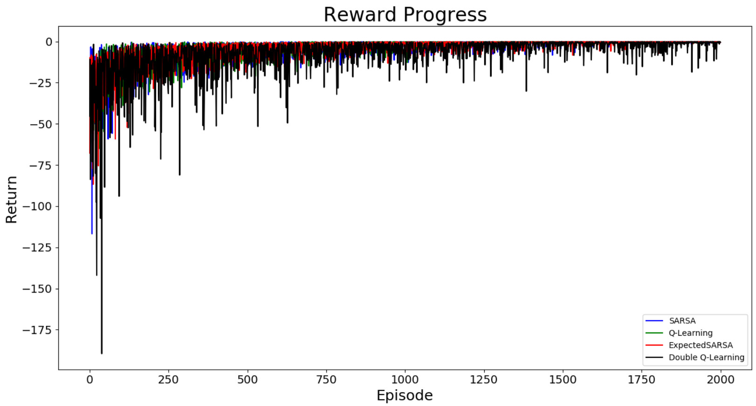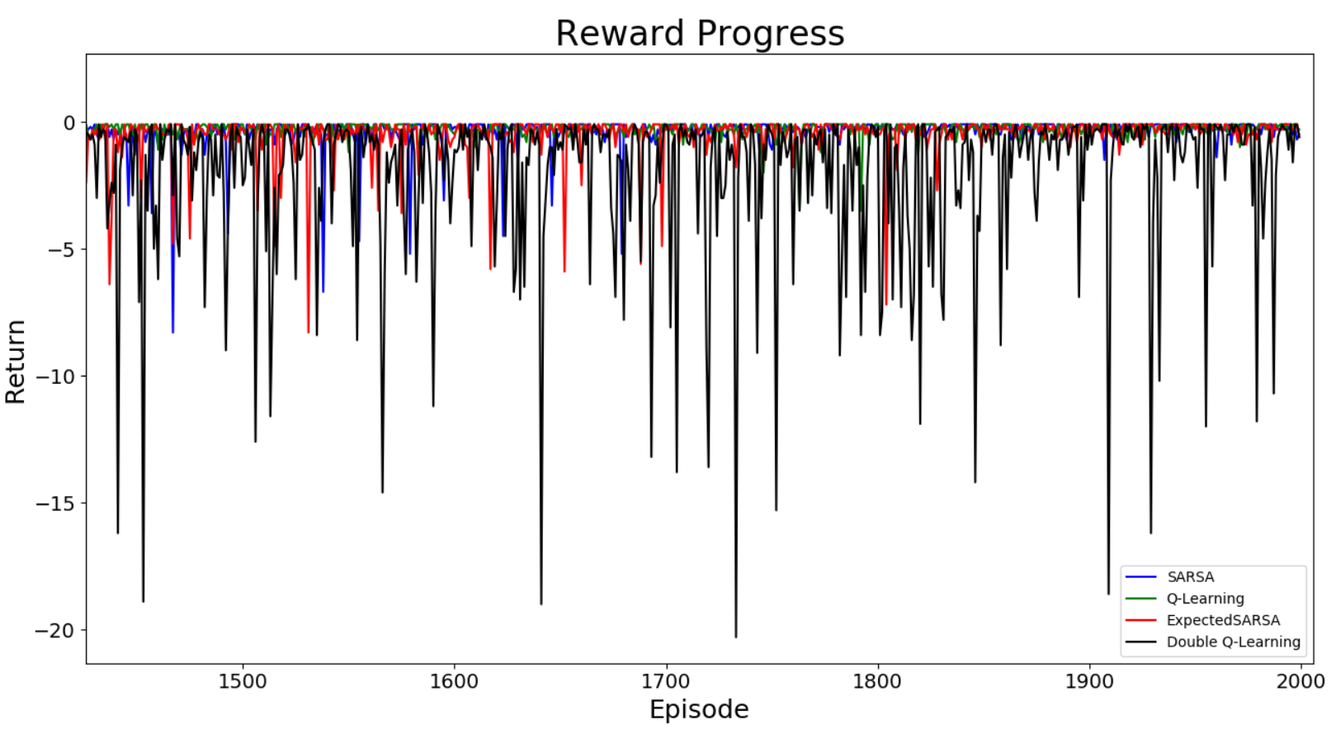

The best reward the algorithms can have is -0.1 because it is 12 steps (shortest-path) far from the terminal state. The data below shows different results from Task 2, where Q-Learning has the least variance. Double Q-Learning still varies the most, and a lot. The maximum reward for all four algorithms are the same, but lower than task 1 because the environment became more difficult. All algorithms still have max reward same as the best reward it can possibly get. SARSA and Expected SARSA has higher medians for the last 100 episodes, and Double Q-Learning did poorly, which means that Double Q-learning in general could not find the shortest path due to more exploration. This is expected since double Q-learning have two Q-value functions to interact with, the variance is higher than all the other functions.

SARSA : max reward = -0.1 medLast100= -0.2 varLast100=0.061475

Q-Learning : max reward = -0.1 medLast100= -0.25 varLast100=0.038156

Expected SARSA : max reward = -0.1 medLast100= -0.2 varLast100=0.055876

Double Q-Learning : max reward = -0.1 medLast100= -0.4 varLast100=10.323384

### SARSA

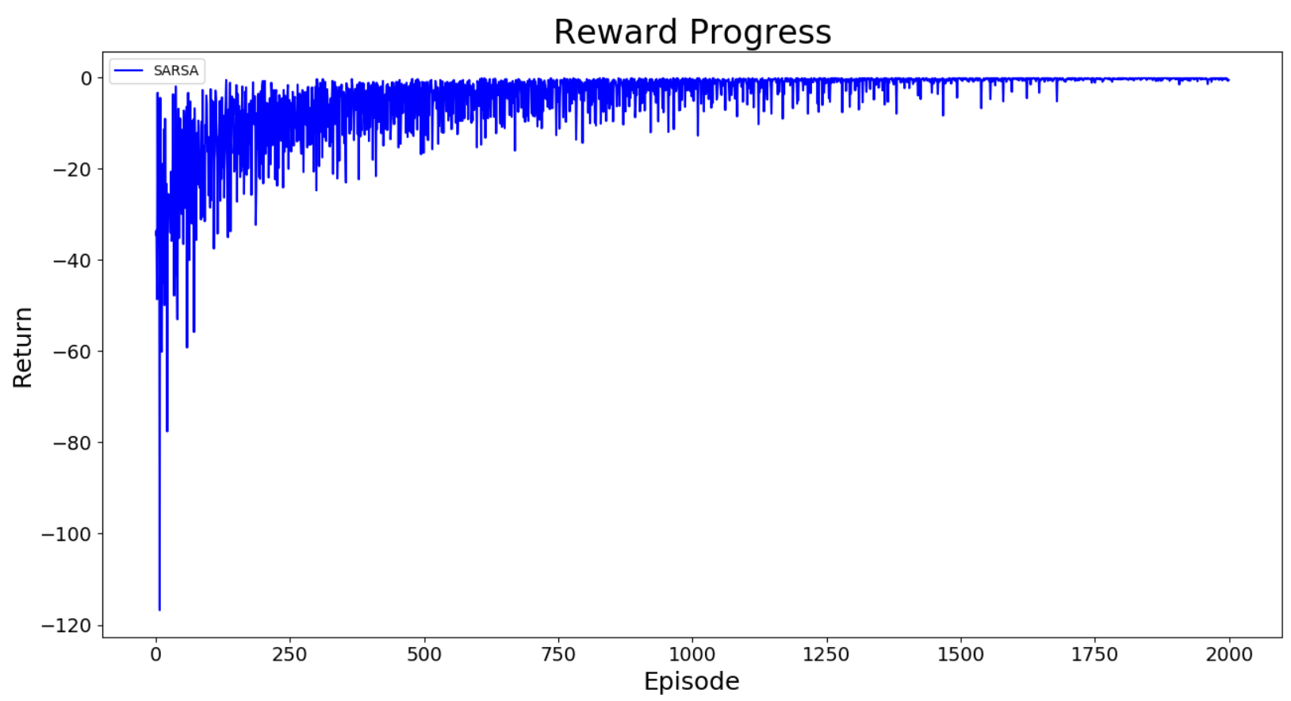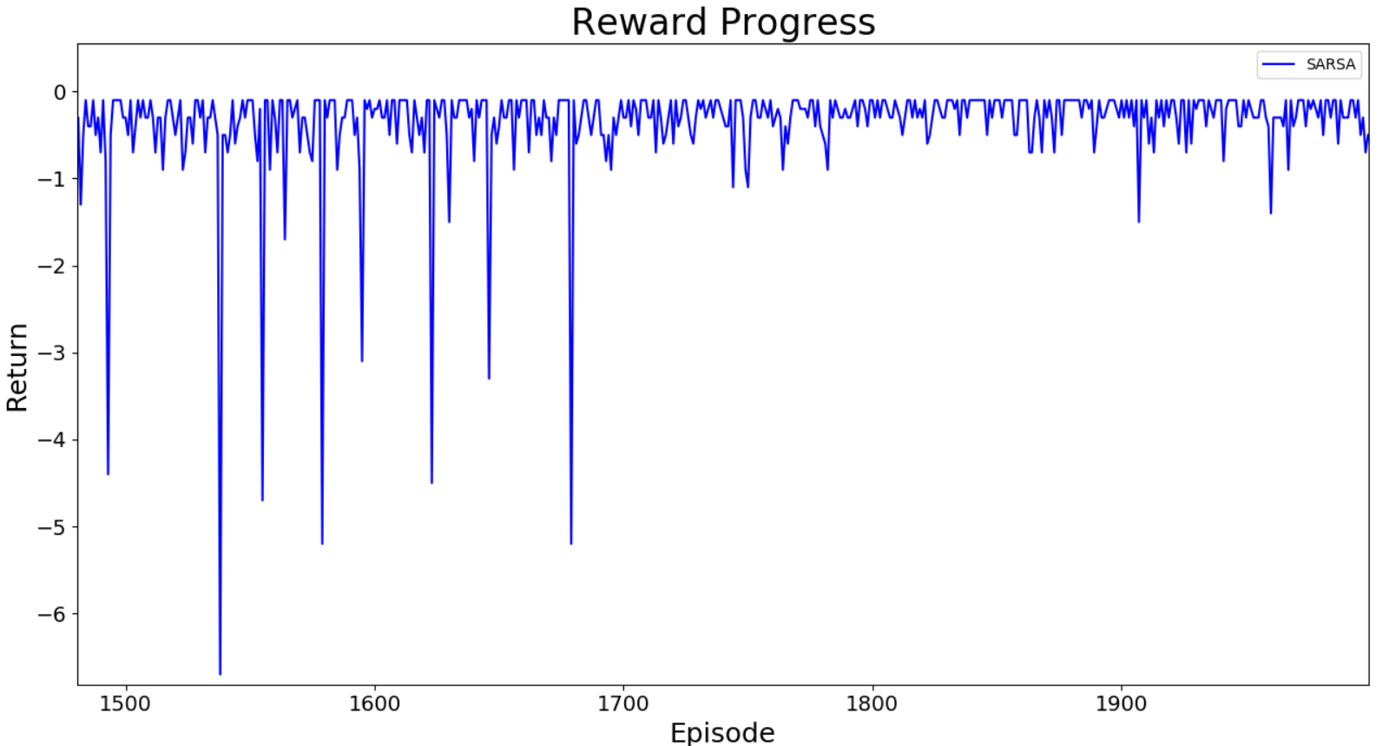

(SARSA) Episode 1500: Length=13 Total return = -0.3 Median100=-0.3 Variance100=1.313411

(SARSA) Episode 1600: Length=12 Total return = -0.2 Median100=-0.3 Variance100=0.947624

(SARSA) Episode 1700: Length=13 Total return = -0.3 Median100=-0.3 Variance100=0.552876

(SARSA) Episode 1800: Length=11 Total return = -0.1 Median100=-0.3 Variance100=0.047804

(SARSA) Episode 1900: Length=11 Total return = -0.1 Median100=-0.1 Variance100=0.0282

### Q-Learning

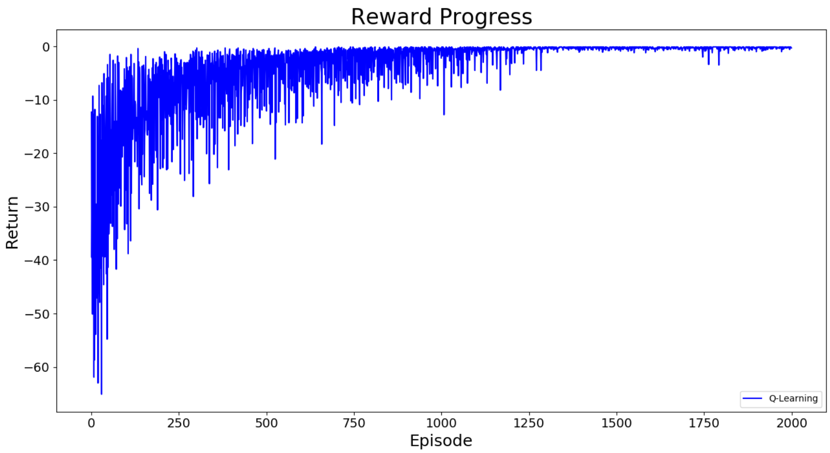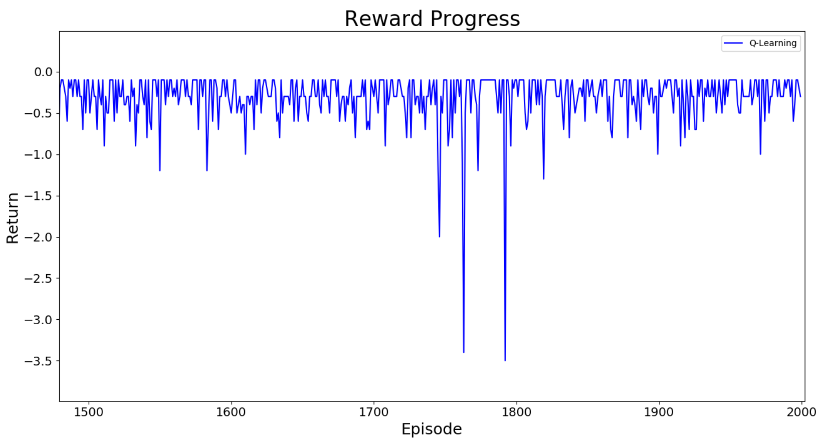

(Q-Learning) Episode 1500: Length=11 Total return = -0.1 Median100=-0.3 Variance100=0.050796

(Q-Learning) Episode 1600: Length=15 Total return = -0.5 Median100=-0.3 Variance100=0.057936

(Q-Learning) Episode 1700: Length=13 Total return = -0.3 Median100=-0.3 Variance100=0.037411

(Q-Learning) Episode 1800: Length=11 Total return = -0.1 Median100=-0.2 Variance100=0.290416

(Q-Learning) Episode 1900: Length=11 Total return = -0.1 Median100=-0.25 Variance100=0.052875

### Expected SARSA

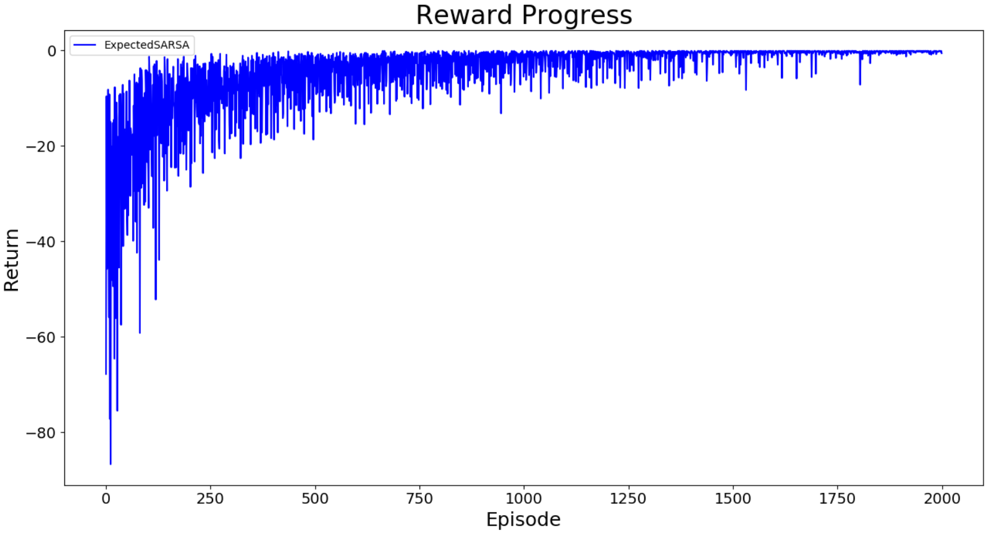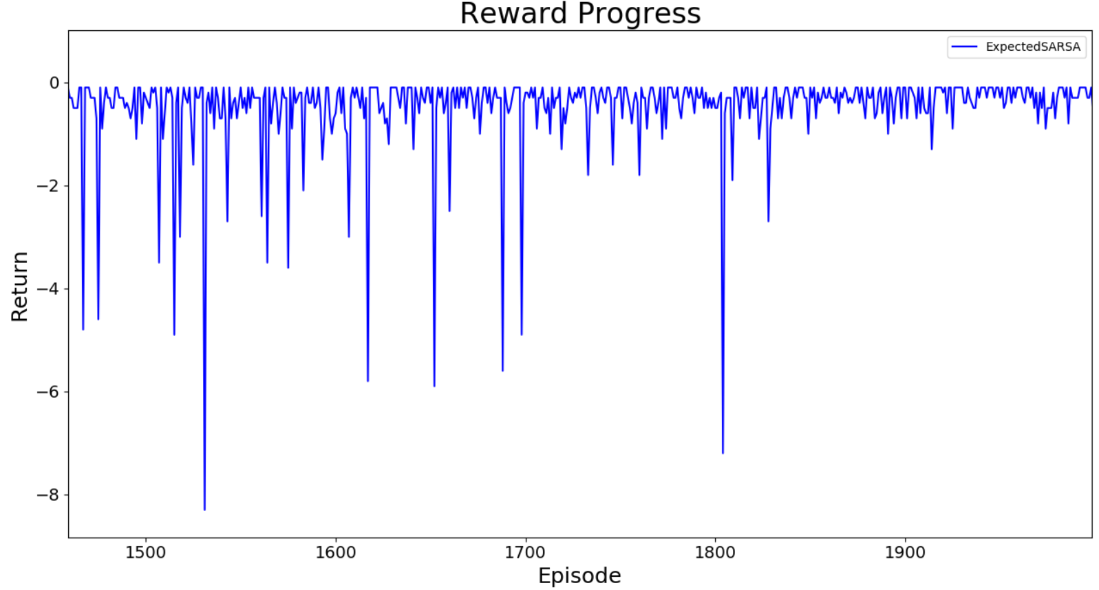

(ExpectedSARSA) Episode 1500: Length=13 Total return = -0.3 Median100=-0.3 Variance100=1.358256

(ExpectedSARSA) Episode 1600: Length=14 Total return = -0.6 Median100=-0.3 Variance100=1.320851

(ExpectedSARSA) Episode 1700: Length=12 Total return = -0.2 Median100=-0.3 Variance100=1.222171

(ExpectedSARSA) Episode 1800: Length=15 Total return = -0.5 Median100=-0.3 Variance100=0.118771

(ExpectedSARSA) Episode 1900: Length=11 Total return = -0.1 Median100=-0.3 Variance100=0.598179

### Double Q-Learning

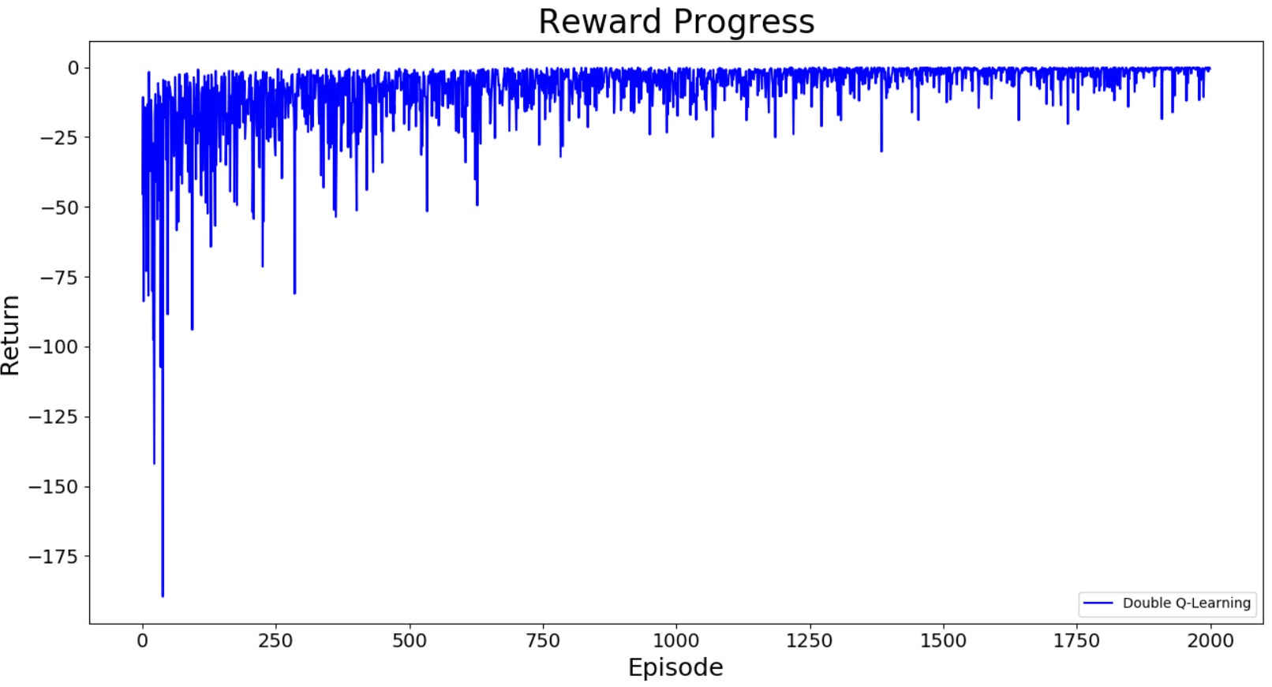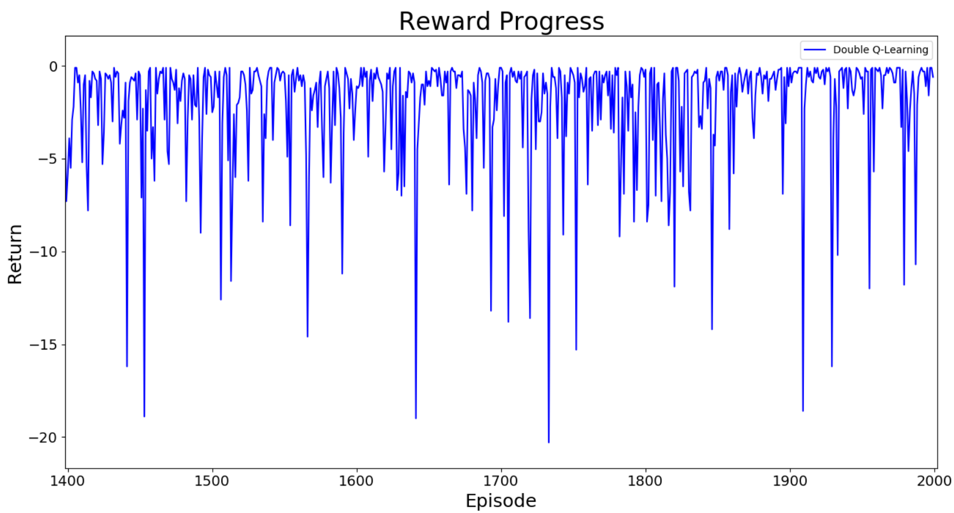

(Double Q-Learning) Episode 1500: Length=35 Total return = -2.5 Median100=-0.9 Variance100=8.8181

(Double Q-Learning) Episode 1600: Length=21 Total return = -1.1 Median100=-1.05 Variance100=8.153091

(Double Q-Learning) Episode 1700: Length=11 Total return = -0.1 Median100=-0.9 Variance100=7.813011

(Double Q-Learning) Episode 1800: Length=12 Total return = -0.2 Median100=-0.75 Variance100=12.632451

(Double Q-Learning) Episode 1900: Length=11 Total return = -0.1 Median100=-0.7 Variance100=8.031764

### More comparison graphs

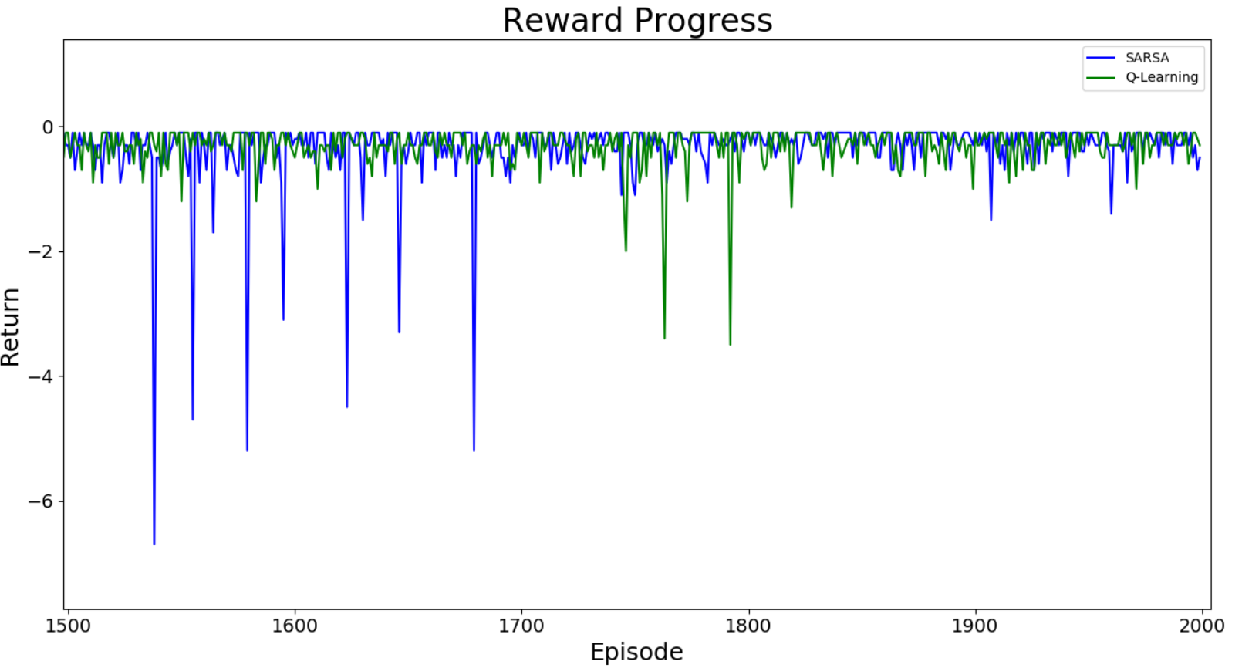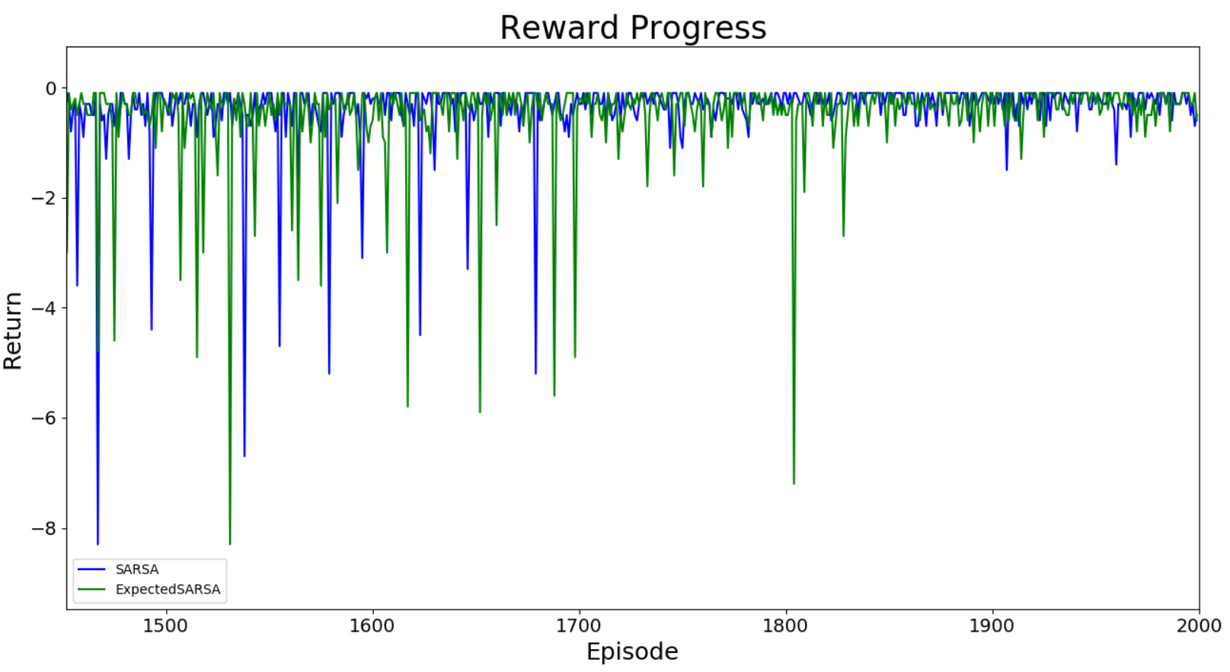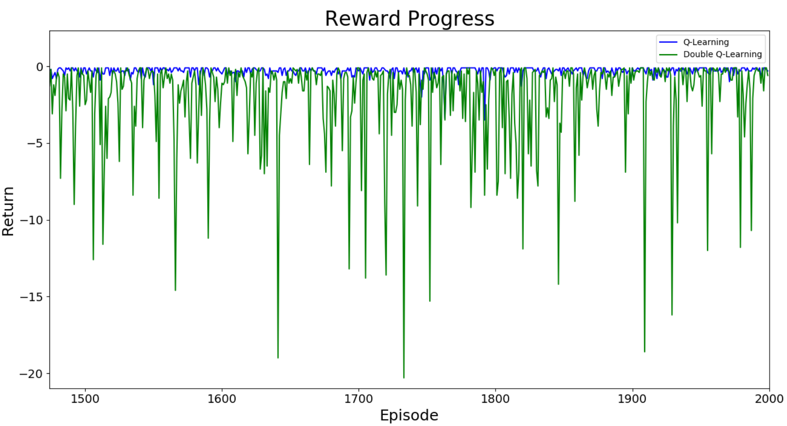

## Task 3

### Overall

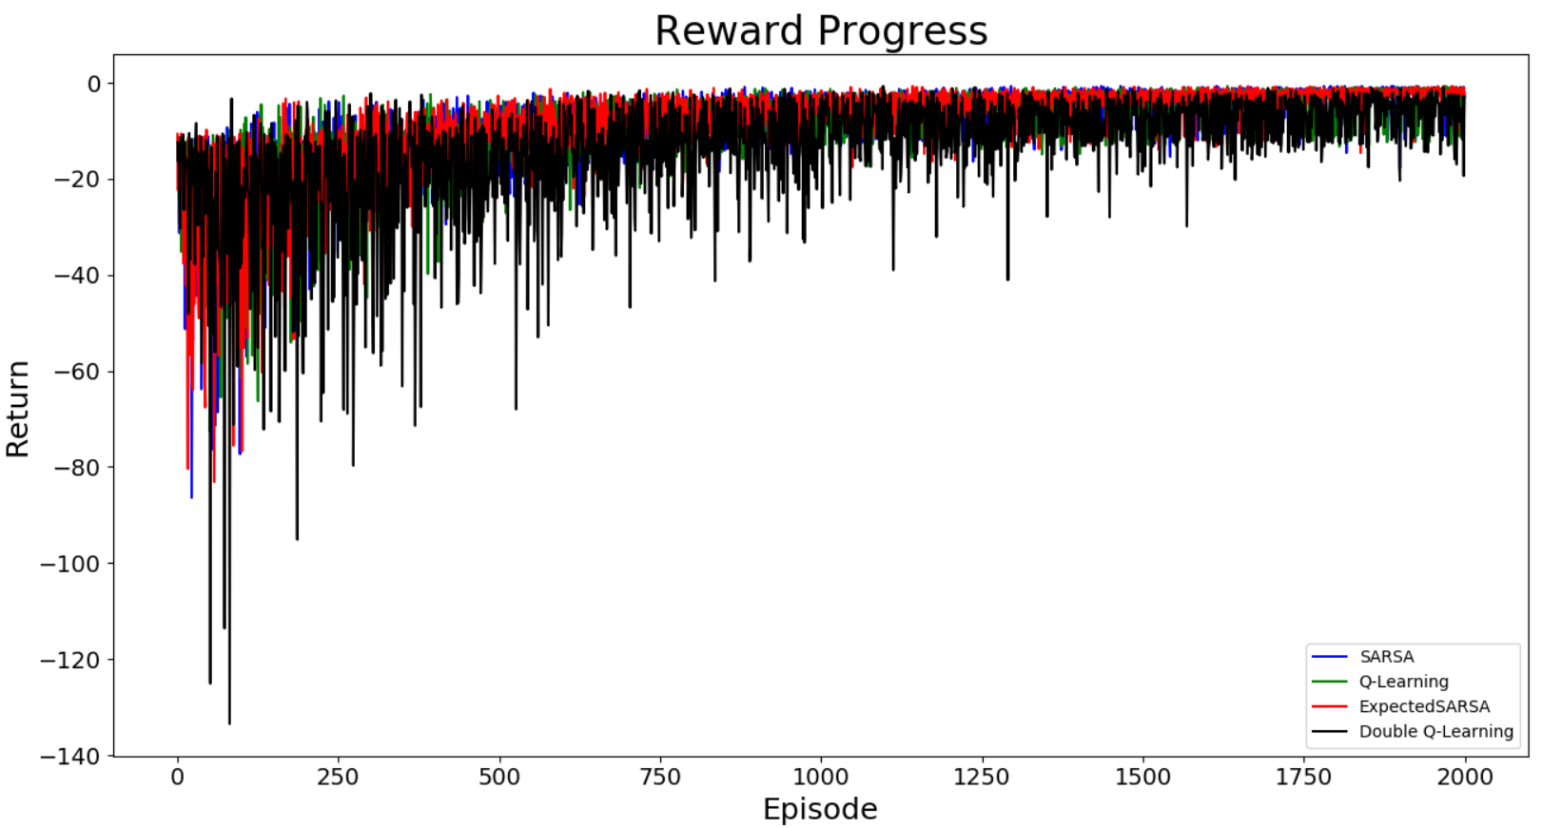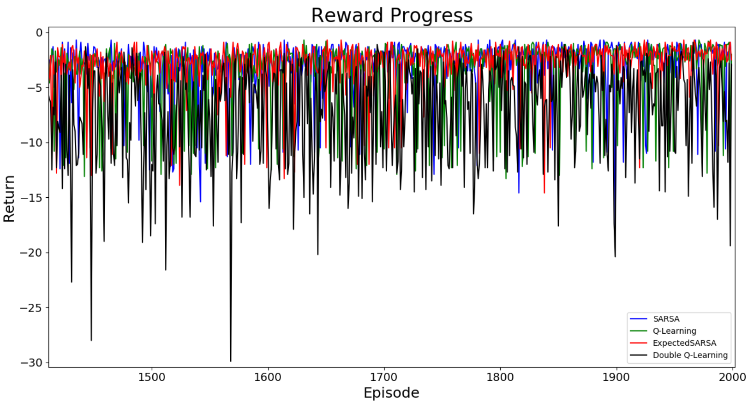

As shown in data below, Q Learning had the highest median for the last 100 episodes, and Expected SARSA was the most stable algorithm for task 3.

The best reward any algorithms can get is -0.7, and all four algorithms have got that as maximum reward. However, since there are more pit and wall blocks, on average, they did poorly than they did on other tasks with the same number of episodes. Also, the variance has been increased a lot more than task 2, but it still shows Double Q-Learning has the worst variance.

SARSA : max reward = -0.7 medLast100=-1.8 varLast100=5.3621

Q-Learning : max reward = -0.7 medLast100=-1.75 varLast100=8.790691

Expected SARSA : max reward = -0.7 medLast100=-1.85 varLast100=2.726516

Double Q-Learning : max reward = -0.7 medLast100=-5.05 varLast100=15.860171

### SARSA

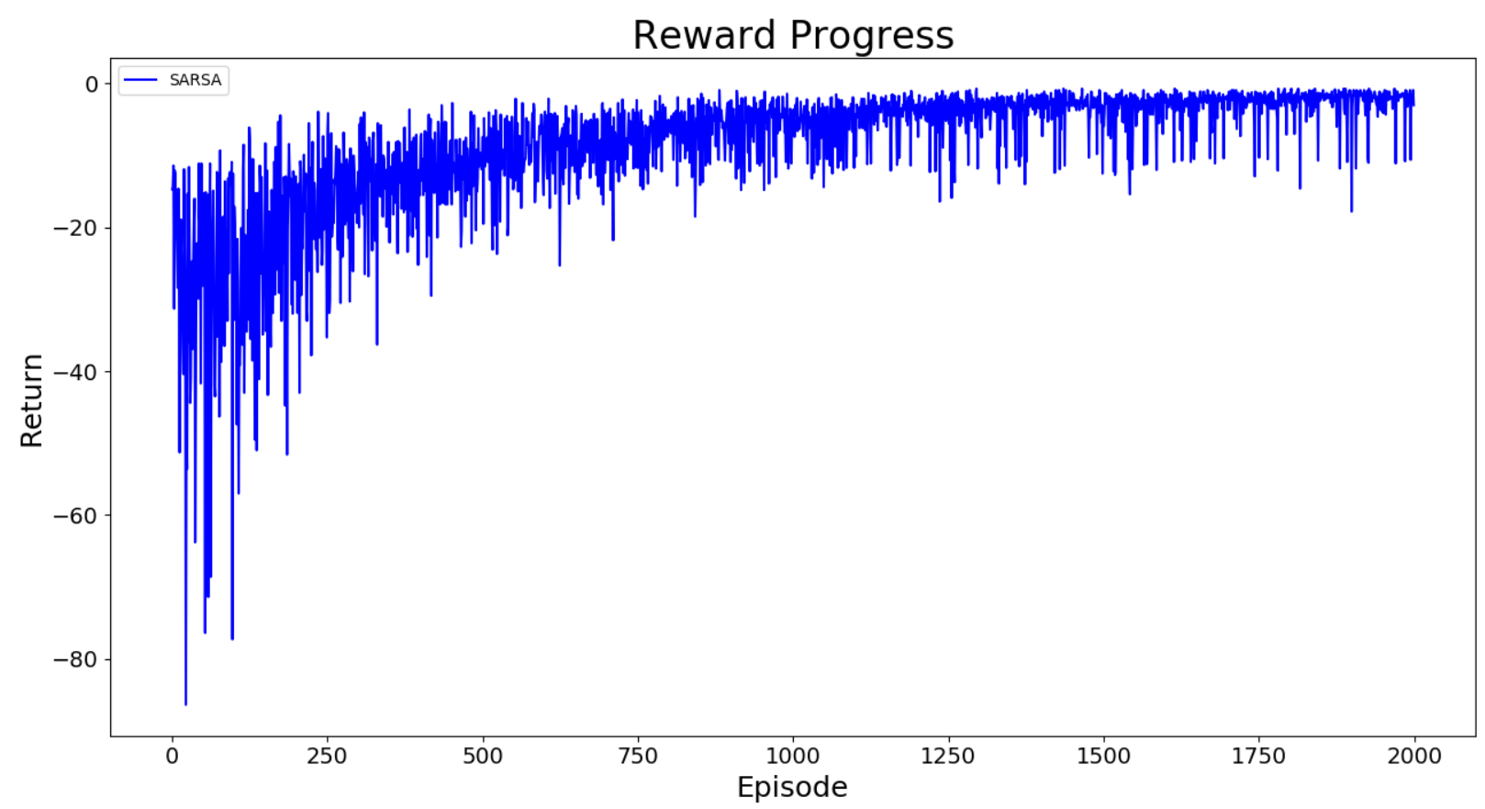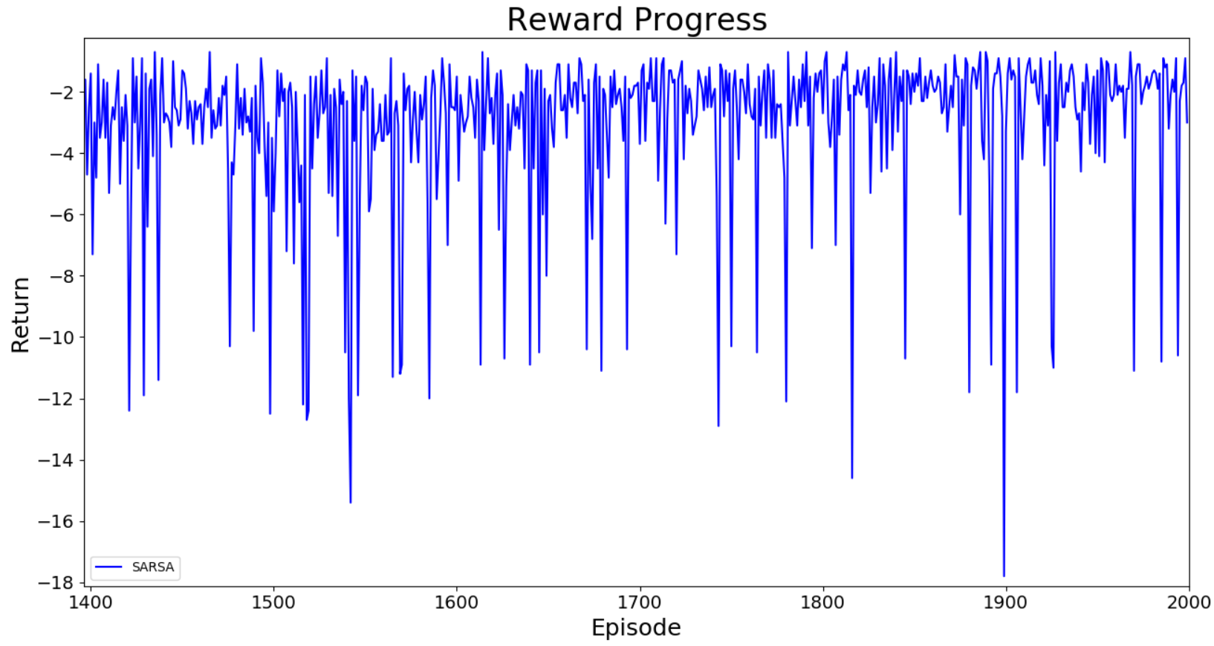

(SARSA) Episode 1500: Length=65 Total return = -5.9 Median100=-2.9 Variance100=5.718184

(SARSA) Episode 1600: Length=25 Total return = -1.5 Median100=-2.65 Variance100=10.419499

(SARSA) Episode 1700: Length=47 Total return = -3.7 Median100=-2.2 Variance100=6.067675

(SARSA) Episode 1800: Length=37 Total return = -2.7 Median100=-2.05 Variance100=4.807504

(SARSA) Episode 1900: Length=43 Total return = -3.3 Median100=-1.8 Variance100=7.532116

### Q-Learning

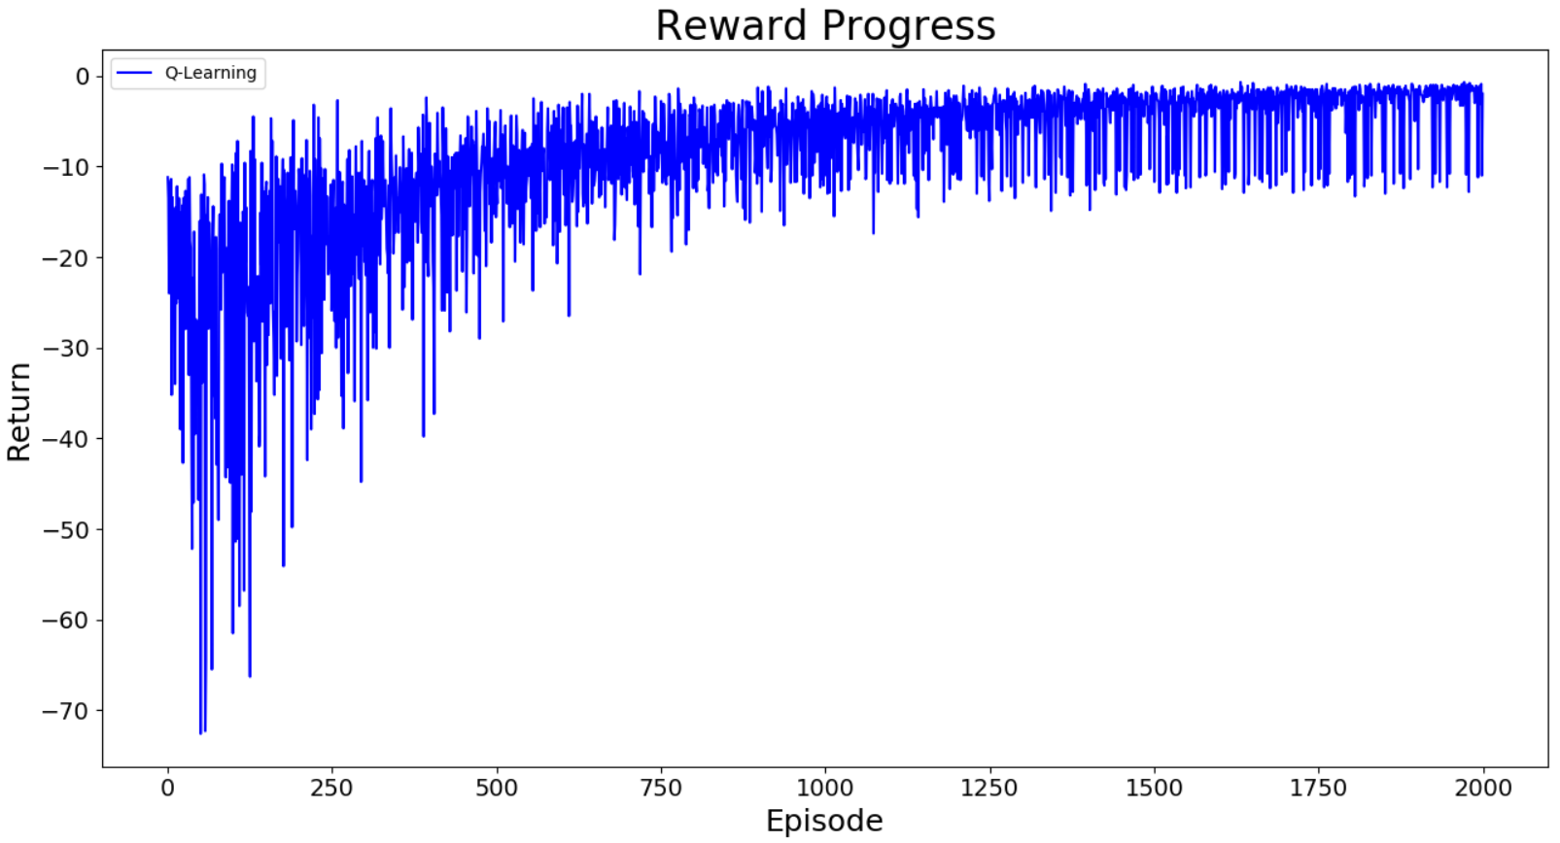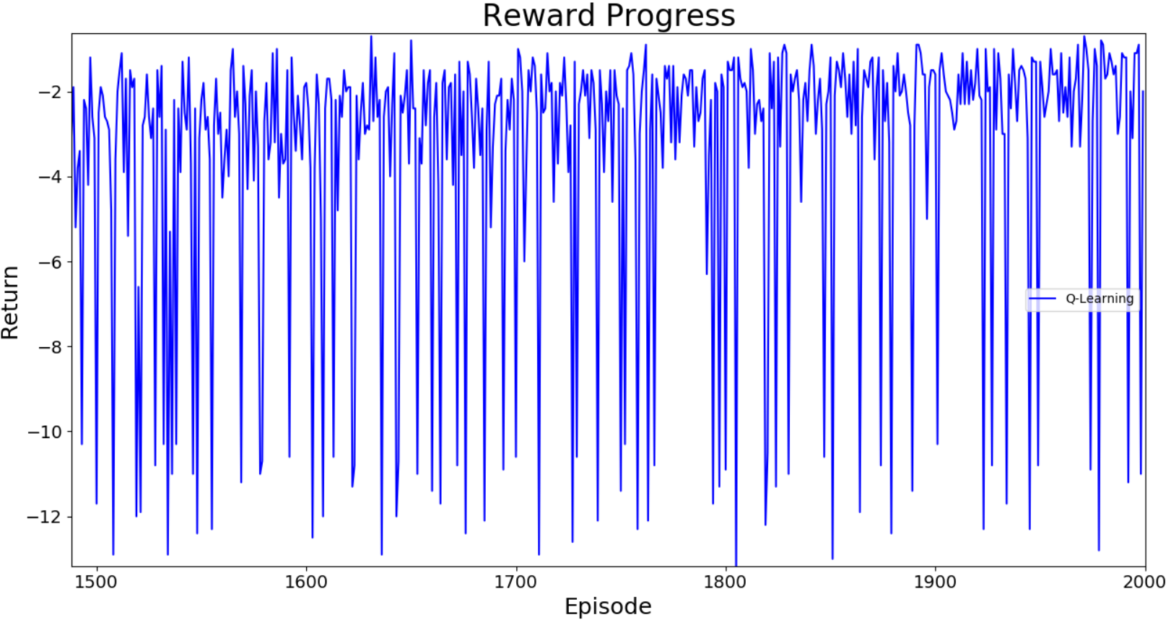

(Q-Learning) Episode 1500: Length=15 Total return = -11.7 Median100=-3.1 Variance100=11.507075

(Q-Learning) Episode 1600: Length=28 Total return = -1.8 Median100=-2.8 Variance100=11.432324

(Q-Learning) Episode 1700: Length=6 Total return = -10.6 Median100=-2.4 Variance100=11.403819

(Q-Learning) Episode 1800: Length=9 Total return = -10.9 Median100=-2.1 Variance100=10.143556

(Q-Learning) Episode 1900: Length=26 Total return = -1.6 Median100=-1.9 Variance100=10.562744

### Expected SARSA

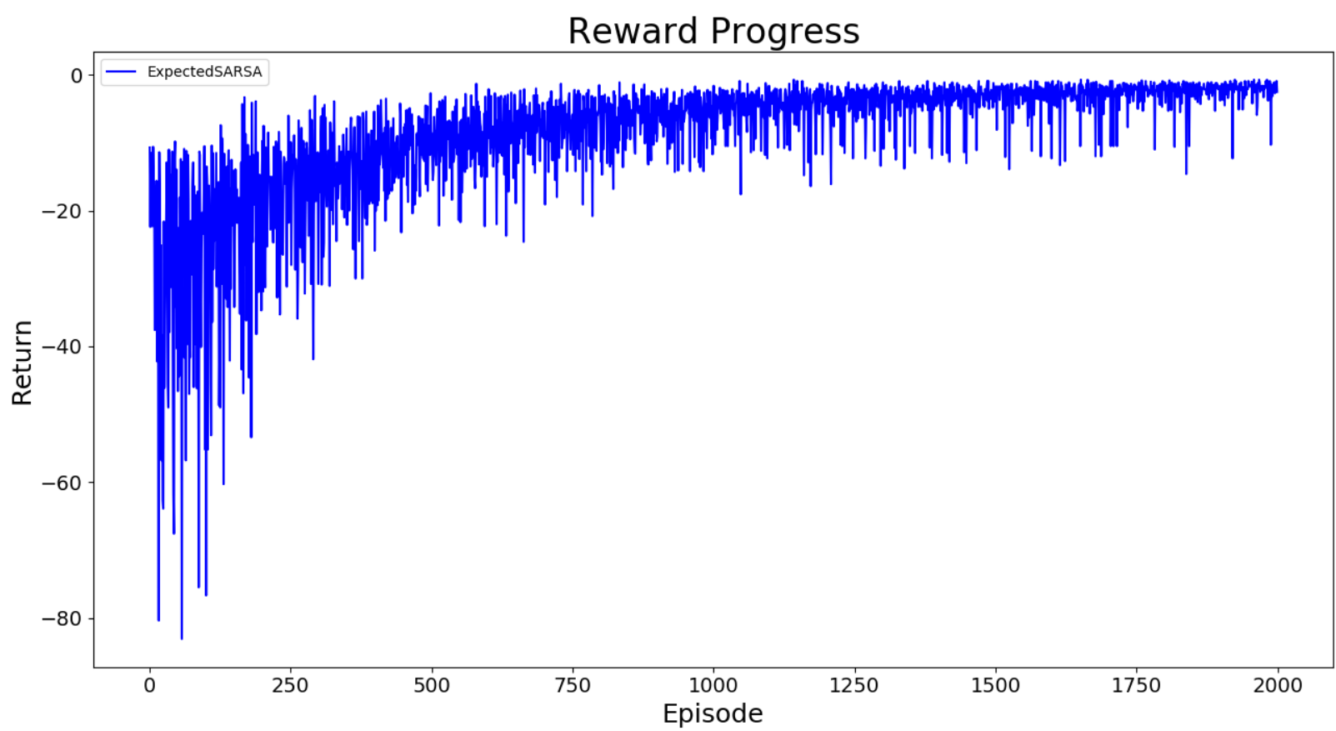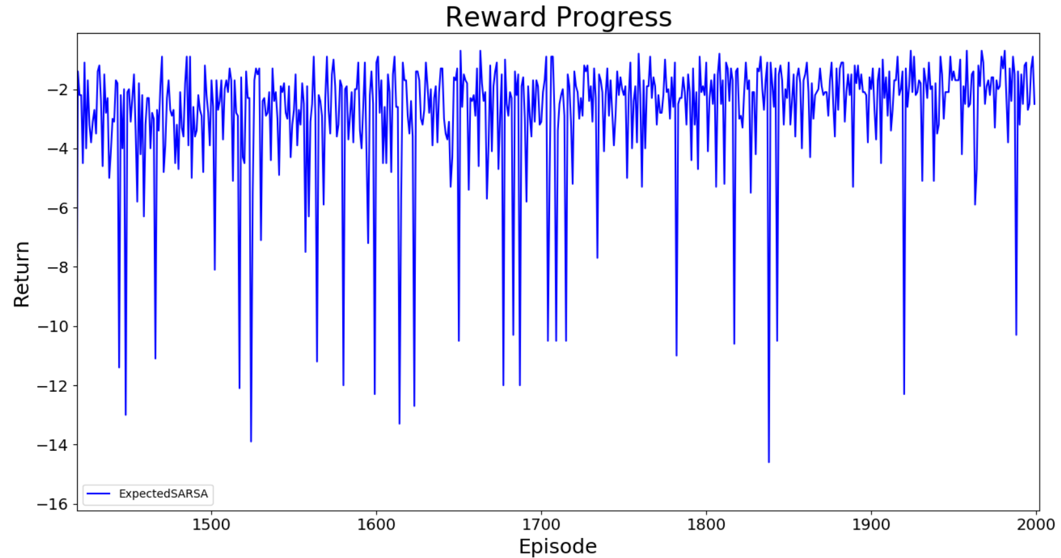

(ExpectedSARSA) Episode 1500: Length=27 Total return = -1.7 Median100=-3.0 Variance100=5.895516

(ExpectedSARSA) Episode 1600: Length=21 Total return = -1.1 Median100=-2.45 Variance100=6.412099

(ExpectedSARSA) Episode 1700: Length=35 Total return = -3.1 Median100=-2.3 Variance100=6.359036

(ExpectedSARSA) Episode 1800: Length=21 Total return = -1.1 Median100=-2.2 Variance100=3.8683

(ExpectedSARSA) Episode 1900: Length=30 Total return = -2.0 Median100=-2.0 Variance100=3.912524

### Double Q-Learning

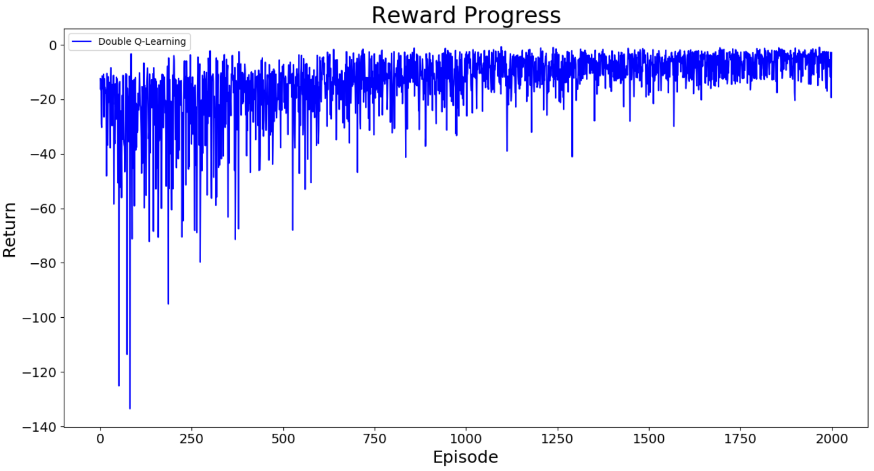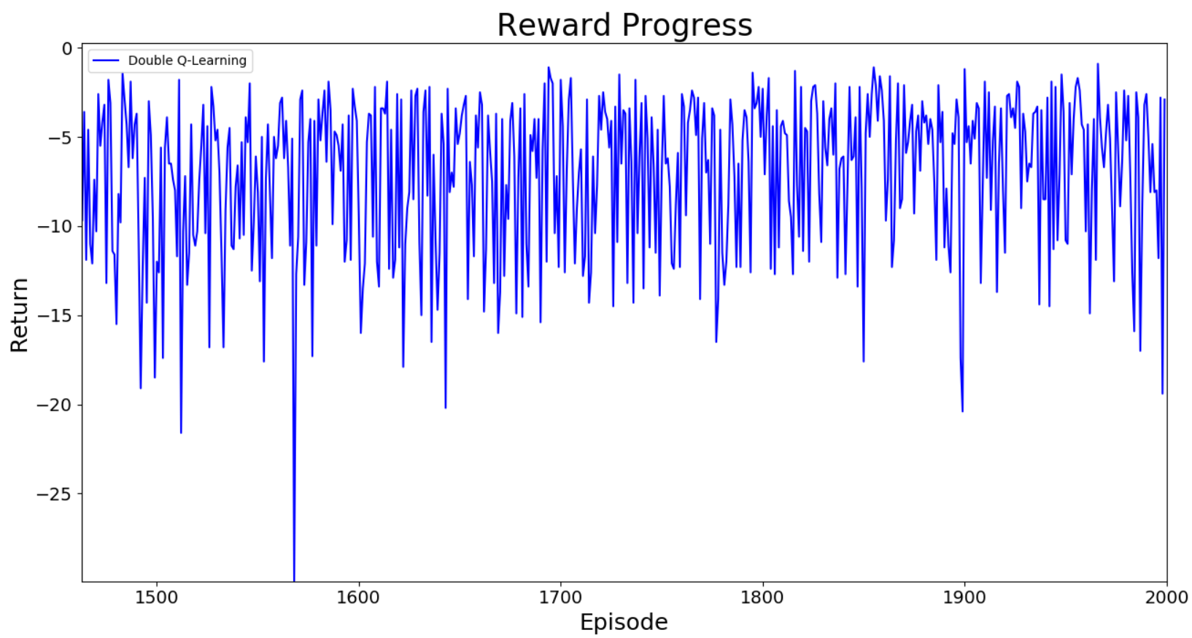

(Double Q-Learning) Episode 1500: Length=124 Total return = -12.0 Median100=-7.85 Variance100=23.272664

(Double Q-Learning) Episode 1600: Length=105 Total return = -9.5 Median100=-6.5 Variance100=22.321464

(Double Q-Learning) Episode 1700: Length=28 Total return = -1.8 Median100=-6.7 Variance100=21.957091

(Double Q-Learning) Episode 1800: Length=31 Total return = -2.3 Median100=-6.1 Variance100=16.4615

(Double Q-Learning) Episode 1900: Length=22 Total return = -1.2 Median100=-4.95 Variance100=15.988491

### More Comparison Graphs

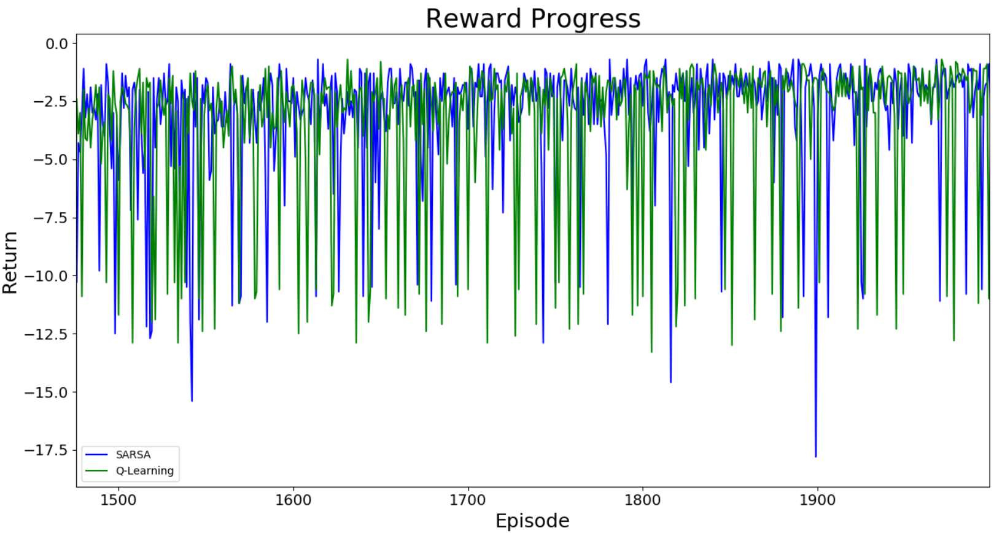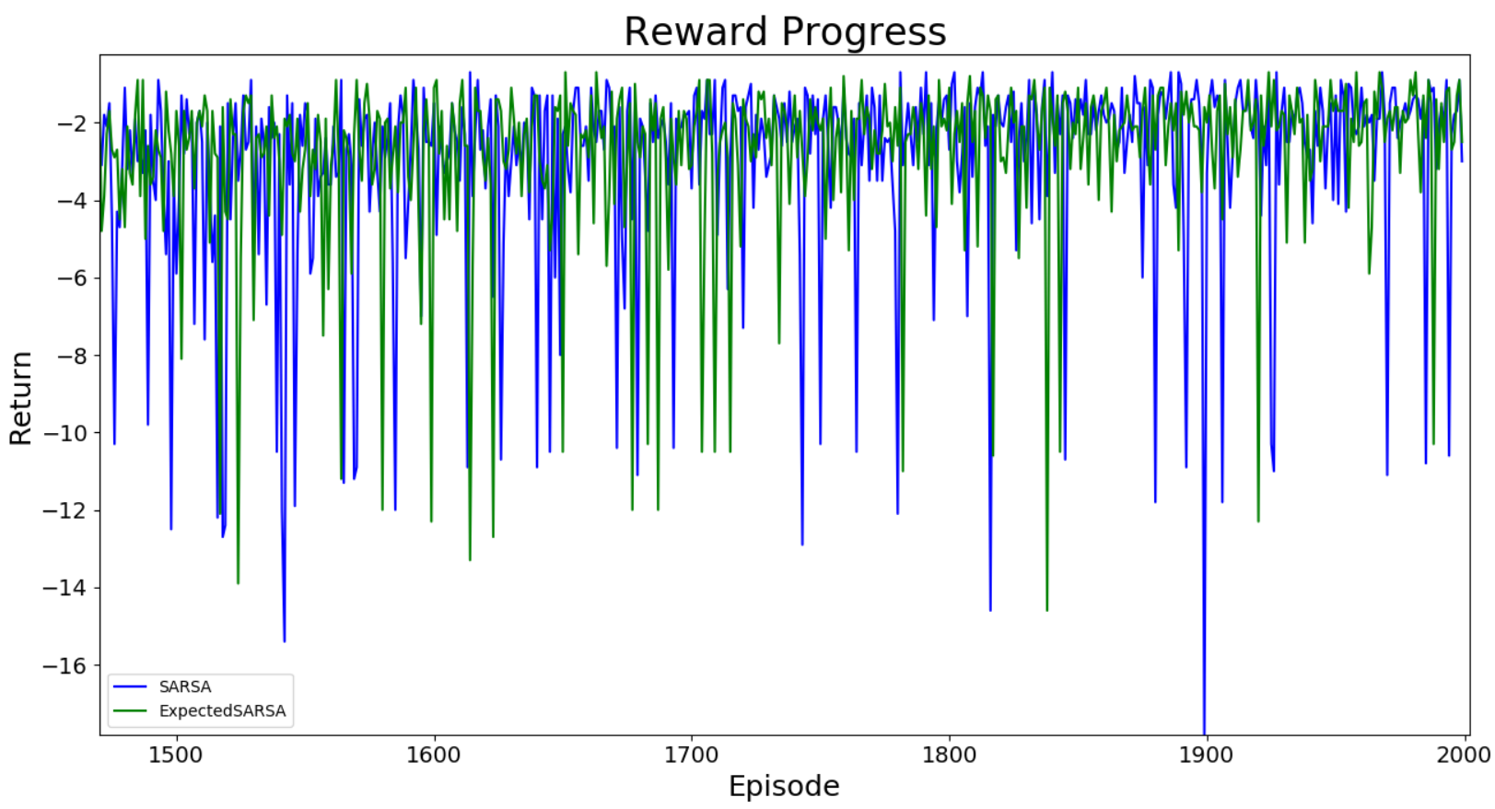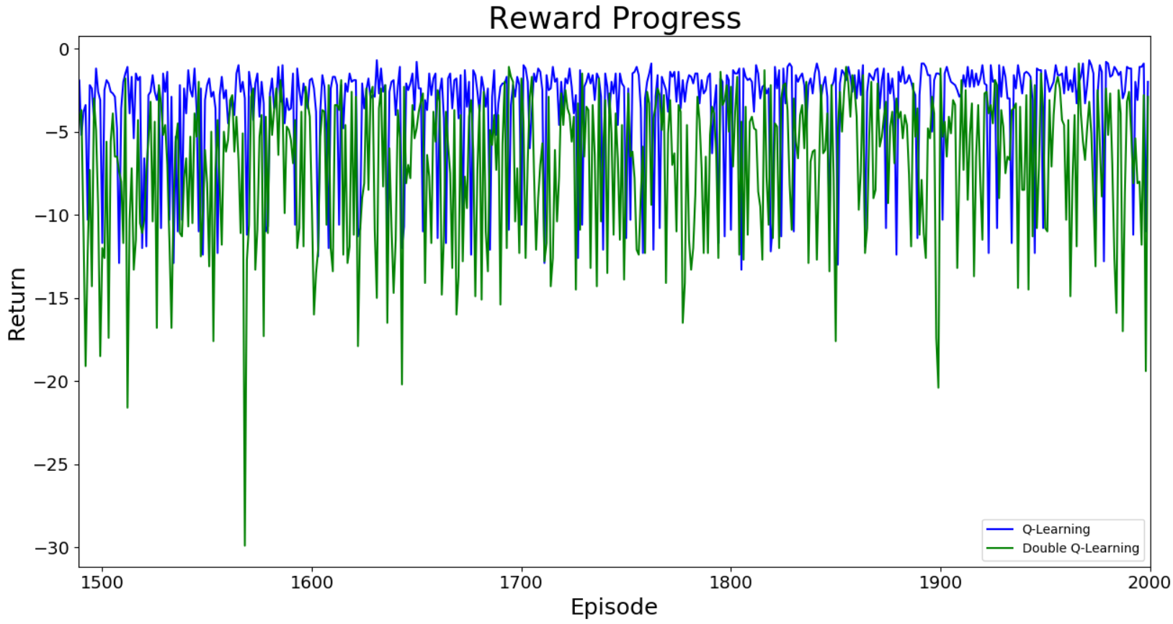

# Conclusion

In general, it is shown that as tasks get more difficult, the algorithms converged slower and outputted lower rewards like we expected. Double Q-Learning varies the most, because it uses two Q-value functions to update and thus, inevitably explores more. Expected SARSA works the most stable and quite accurate throughout the tasks. This is because SARSA calculates Q-value function considering all possible actions rather than just one greedy-algorithm-valued action.